 

### National University of Computer and Emerging Sciences



Carpooling as a Solution to Rising Transport Costs and Traffic Congestion

### Final Report Team

Ghulam Mohyudin 21L-5249

Anzar Zahid 21L-5264

Waleed Malik 21L-5248

Umamah Hussain 21L-1858

Yasoob Tahavi 21I-0395

### Supervised by

### Miss. Naima Chaudry

**FAST School of Computing**

### National University of Computer and Emerging Sciences Lahore Campus, Pakistan

**November 2023**

# Abstract

Urban areas worldwide grapple with the dual challenges of escalating transport costs and persistent traffic congestion, and Lahore, Pakistan, is no exception. This article delves into the pressing issues faced by commuters in Lahore, emphasizing the economic strain imposed by increasing petrol prices and the adverse effects of unregulated traffic on the city's roads. A survey conducted in the region revealed that a significant portion of the population regularly contends with challenges arising from high petrol prices, indicating a critical need for a sustainable solution. In response, this report advocates for the implementation of a carpooling application as an effective means to alleviate the financial burdens associated with individual transportation while simultaneously addressing broader concerns such as traffic congestion, pollution, and environmental sustainability. The literature review underscores the complexity of Lahore's traffic congestion problem, attributing it to factors like unruly driving behavior, inadequate public transport, and a surge in private vehicle ownership. Various studies suggest potential solutions, ranging from adopting innovative town planning concepts to implementing efficient mass transit systems. The proposed carpooling application aims to establish a shared transportation model by connecting individuals with similar schedules and locations. Through the formation of carpooling groups, comprising a designated driver and passengers, the application seeks to reduce the economic strain on individuals by optimizing transport costs. Survey responses indicate a substantial openness among respondents to embrace a carpooling initiative, with a majority expressing dissatisfaction with current transportation options and a notable concern for the environmental impact of individual commuting. The proposed carpooling solution emerges as a promising strategy to counter rising transport costs and traffic congestion in Lahore. By fostering a sense of community and shared responsibility, the envisioned carpooling app stands poised to offer a cost-efficient, convenient, and environmentally sustainable alternative to traditional transportation methods.

### Table of Contents

Table of Contents

Abstract 2

Table of Contents 3

Chapter 1: Introduction 4

1.1 Purpose of this Report 4

1.2 Intended Audience 4

Chapter 2: Project Vision 6

2.2 Problem Statement 6

2.3 Problem Elaboration 6

2.4 Goals and Objectives 7

2.4.1 Cost Efficiency 7

2.4.2 Traffic Reduction 7

2.4.3 Pollution Reduction 7

2.4.4 Community Building 7

2.4.5. Accessibility Enhancement 7

2.4.6. Behavioral Shift towards Sustainable Transportation 7

2.4.7. Scalability and Replicability 7

2.5 Project Scope 8

Chapter 3: Literature Review / Related Work 10

Chapter 4: Software Requirements Specifications 12

4.1 Functional Requirements 12

4.1.1 User Authentication Module 12

4.1.2 Profile Customization Module 12

4.1.4 Dynamic Schedule Adjustment Module 12

4.1.5 Predictive Cost Modeling Module 12

4.2 Design Constraints 12

4.3 Risks 12

Chapter 5: High Level and Low-Level Design 13

5.1 High-Level Design 13

5.2 Low-Level Design 13

Chapter 6: Conclusion and Future Work 14

6.1 Conclusion 14

6.2 Future Work 14

References 15

Appendix 16

# Chapter 1: Introduction

The increasing costs linked to individual transportation, fueled by rising petrol prices, pose a significant challenge to the general public. This was quite evident from a survey conducted which showed that 26.9% people always face challenges due to high petrol prices while 50% face this problem quite often. While the price of petrol is beyond direct control, our report aims to provide a practical and sustainable solution to mitigate the financial strain on individuals. Carpooling, as a shared transportation model, holds the potential to not only reduce the economic burden but also address broader issues such as traffic congestion, pollution, and environmental sustainability.

The issue is that the people are facing high transport costs due to petrol prices. The goal is for carpooling application to be the main mode for transport to alleviate financial burden on the people. The literature review discusses the impacts of traffic congestion, pollution due to traffic and the openness of people to carpooling. The survey showed that people would very likely use a carpooling app for their transport. The application would work like this: people who are near to each other and have similar schedules are connected, where one person is the designated driver and the others are the passengers. In conclusion, a carpool application would be recommended to create so that people can use a cheaper version of transport.

# Purpose of this Report

The purpose of the report is to report on how well a carpooling application would be for the people of Lahore as it would provide a mode of transport that takes a less toll on their wallets.

In the contemporary urban landscape, the intersection of rising transport costs and exacerbated traffic congestion presents a formidable challenge, particularly in cities like Lahore, Pakistan. This report embarks on an exploration of the intricate dynamics at play within this challenging paradigm, aiming to dissect the multifaceted issues faced by the populace and propose a viable and sustainable solution in the form of a carpooling application.

The escalating costs associated with individual transportation, primarily fueled by the incessant surge in petrol prices, have become an acute concern for the citizens of Lahore. A thorough examination, substantiated by a recent survey, elucidates that a substantial percentage of the population contends with persistent challenges arising from the financial burden of high petrol prices.

# Intended Audience

The intended audience for this comprehensive report encompasses a diverse spectrum of stakeholders whose lives, perspectives, and decision-making processes are intricately interwoven with the urban transportation dynamics of Lahore. Recognizing the multifaceted nature of the issues at hand and the far-reaching implications of the proposed carpooling solution, the report is tailored to cater to the following key groups:

Urban Commuters in Lahore: At the heart of this report are the individuals who navigate the intricate web of Lahore's urban transportation on a daily basis. Whether these commuters are students, professionals, or residents, this report speaks directly to their lived experiences, financial concerns, and aspirations for a more sustainable and efficient mode of transportation. By understanding their challenges and aspirations, the report endeavors to resonate with the diverse demographic that constitutes Lahore's commuting population.

Transportation Authorities and Urban Planners: The report extends its reach to municipal authorities, urban planners, and decision-makers responsible for shaping the transportation infrastructure of Lahore. By providing a comprehensive analysis of the challenges faced by the city's commuters, coupled with a pragmatic solution in the form of a carpooling application, the report aims to serve as a strategic guide for those vested with the responsibility of optimizing urban mobility. Transportation authorities and planners will find insights into the potential impact of carpooling on traffic management and the overall urban landscape.

Environmental Advocates and Sustainability Enthusiasts: Given the growing global concern for environmental sustainability, this report is poised to capture the attention of environmental advocates and sustainability enthusiasts in Lahore. The proposed carpooling solution aligns with eco-conscious endeavors, offering a means to reduce individual carbon footprints and curb the environmental toll imposed by vehicular emissions. Consequently, this report seeks to engage with individuals and organizations dedicated to fostering sustainable practices within urban spaces.

Technology Developers and Innovators: The technological backbone of the proposed carpooling application makes technology developers and innovators a pertinent audience. By elucidating the functionalities and features of the envisioned app, the report invites collaboration from those at the forefront of technological innovation. Developers may find inspiration, and innovators may identify opportunities to contribute to a solution that transcends conventional transportation norms.

Government and Policy Makers: Government officials and policymakers occupy a critical space in the intended audience, as their decisions profoundly influence the urban infrastructure and policies that shape transportation dynamics. The report offers a holistic understanding of the challenges faced by Lahore's commuters and proposes a community-driven, economically viable, and environmentally sustainable solution. It aims to be a resource for policymakers seeking actionable strategies to enhance urban mobility and address the economic and environmental concerns of their constituents.

In essence, the extended intended audience comprises a diverse array of individuals and groups whose roles, perspectives, and actions intersect with the intricate tapestry of urban transportation in Lahore. The report seeks to resonate with each stakeholder, offering tailored insights and perspectives that align with their specific vantage points within the larger urban ecosystem.

# Chapter 2: Project Vision

* 1. **Problem Domain Overview**

The carpooling application basically registers a person to the database. Then the application connects people who live near each other and who have similar schedules throughout the day. Then one person is set to be the designated driver with the person’s own car and the others will be passengers. The passengers will then pay the designated driver their share per month for the cost of transport. The designated driver and the passengers will be considered a ‘carpooling group’. Other people can join the group if they match the conditions expressed earlier. The cost of transport decreases for every passenger that joins the carpooling group until the capacity of the car is reached.

# Problem Statement

The problem at hand in Lahore is twofold: escalating transport costs and persistent traffic congestion. Soaring petrol prices have imposed a financial strain on individuals, while chaotic roadways and inefficient public transport exacerbate daily commutes. The resultant economic and lifestyle implications underscore the pressing need for a comprehensive solution. This problem statement aims to address the urgent challenges faced by Lahore's residents, seeking to alleviate the financial burdens imposed by rising transport costs and simultaneously mitigate the detrimental impact of traffic congestion on daily life in the city.

# Problem Elaboration

The elaboration of the problem underscores the multifaceted challenges stemming from the rising transportation prices in Lahore. As petrol costs escalate, the quest for more affordable travel options intensifies. The existing public transport system falls short of meeting the needs and expectations of the populace, a sentiment echoed by survey respondents. Traditional alternatives like bikes and rickshaws, while cost-effective, might not be universally suitable. Moreover, popular ride-hailing apps, such as Careem and InDrive, impose fees that are often deemed exorbitant, rendering them financially inaccessible for a significant portion of the population.

The sub-problems addressed by the proposed carpooling application extend beyond cost considerations. One notable challenge is the escalating congestion on city roads, exacerbated by the burgeoning number of individual vehicles. By facilitating shared rides, the carpooling application aims to alleviate this strain, optimizing road usage and contributing to a smoother flow of traffic. Additionally, the initiative directly targets environmental concerns by reducing the overall number of vehicles on the road, thereby curbing pollution levels. The broader impact envisaged is a tangible reduction in the carbon footprint associated with daily commutes.

Beyond these macro-level issues, the proposed carpooling solution delves into the micro-dynamics of commuter schedules and financial transactions. The intricacies of coordinating schedules between designated drivers and passengers are acknowledged as potential challenges, and the application is designed to streamline this process for optimal efficiency. Furthermore, the establishment of a reliable and transparent system for monthly payments from passengers to designated drivers addresses financial concerns and ensures a fair distribution of costs within the carpooling groups.

In essence, the problem elaboration illuminates the intricate web of challenges associated with rising transport prices in Lahore. By addressing not only the financial barriers but also the environmental and logistical complexities, the proposed carpooling solution emerges as a holistic approach poised to reshape the city's transportation landscape for the benefit of its residents.

# Goals and Objectives

## Cost Efficiency

The app aims to significantly reduce the financial burden of transportation for individuals by promoting shared rides. Through intelligent scheduling and route optimization, we envision a system where the cost per person is substantially lower than conventional transportation methods.

## Traffic Reduction

Through optimized carpooling, our project aims to reduce traffic congestion, leading to more efficient transportation in urban areas. By promoting shared rides, we anticipate a decrease in individual vehicle usage, contributing to a smoother flow of traffic.

## Pollution Reduction

Our application places a strong emphasis on environmental well-being. By encouraging carpooling and minimizing the number of vehicles on the road, we envision a substantial reduction in pollution levels and emissions, contributing positively to air quality and health.

## 2.4.4 Community Building

Beyond the immediate aims of cost efficiency, traffic reduction, and pollution control, our carpooling application aspires to foster a sense of community among commuters. By facilitating shared rides and collaborative scheduling, the project seeks to weave social bonds among individuals with similar commuting patterns. The envisioned carpooling groups are not only pragmatic solutions for economic and environmental concerns but also potential hubs for social interaction, community support, and shared experiences.

## 2.4.5. Accessibility Enhancement

An additional goal of the application is to enhance accessibility for individuals who might face challenges with traditional modes of transportation. By providing a platform for convenient shared rides, the app aims to cater to a diverse demographic, including those with limited mobility, financial constraints, or other barriers to conventional commuting. This inclusive approach aligns with the overarching mission to make transportation more equitable and accessible for all members of the community.

## 2.4.6. Behavioral Shift towards Sustainable Transportation

The project envisions a broader societal impact by influencing a behavioral shift towards sustainable transportation practices. By normalizing and popularizing carpooling, the application aims to instigate a cultural change in how individuals perceive and engage with commuting. The goal is not just to offer a pragmatic solution but to contribute to a larger movement towards environmentally conscious and community-oriented transportation habits.

## 2.4.7. Scalability and Replicability

Another critical objective is to design the carpooling application with scalability and replicability in mind. The goal is not only to address the unique challenges of Lahore but to create a model that can be adapted and implemented in other urban centers facing similar transportation dilemmas. By fostering a scalable solution, the project aims to contribute to a global conversation on sustainable urban transportation, transcending geographical boundaries and cultural contexts.

# Project Scope

The scope of the application starts from the login and signup of a user to the connection between people for carpooling. The list includes:

* Login/Signup  
  The project scope encompasses a user-centric approach by introducing the feature of user profile customization during the login and signup phase. This enhancement allows users to personalize their profiles, incorporating details such as commuting preferences, favored routes, and specific considerations. By tailoring individual profiles, the carpooling application aims to create a more nuanced matching system, enriching the overall user experience and ensuring a more effective and personalized carpooling arrangement.

* Connecting people through the app for carpooling  
  Enriching the connection between carpooling individuals, an integral addition to the project scope is an in-app communication platform. This feature facilitates seamless communication between designated drivers and passengers, enabling them to coordinate schedules, discuss preferences, and address any real-time adjustments. The in-app communication platform enhances the overall user experience and fosters a sense of community among carpooling groups.
* Schedule Building for shared rides  
  Expanding the scope to schedule building, the application incorporates a dynamic schedule adjustment feature. This functionality empowers users to adapt their commuting schedules based on changing needs or unforeseen circumstances. The dynamic scheduling feature ensures flexibility, accommodating the evolving nature of individuals' daily routines, contributing to the adaptability and resilience of the carpooling system.
* Calculation of cost per passenger  
  Complementing the calculation of the cost per passenger, an extended scope involves the integration of predictive cost modeling. Leveraging historical data, fuel prices, and route efficiency metrics, the application offers users a predictive cost estimate for their shared rides. This forward-looking approach empowers users with financial foresight, contributing to a more transparent and informed decision-making process.
* Recalculation of cost if a person leaves the carpooling group|  
  In addressing the intricacies of shared rides, the project scope incorporates a dynamic feature for the recalculation of costs should a participant decide to leave the carpooling group. This functionality ensures fairness and transparency within the system, adapting to the fluid nature of commuting arrangements. When a member exits the carpooling group, the application dynamically adjusts the cost distribution among the remaining participants, preventing undue financial burdens on those who continue to share rides. This feature not only accounts for the ever-changing dynamics of carpooling groups but also promotes a cooperative and equitable financial model, fostering a sense of trust and reliability among users.

* Payment gateway to pay the designated driver  
  Integral to the seamless operation of the carpooling application is the incorporation of a secure and user-friendly payment gateway. This facilitates the smooth transfer of funds from passengers to the designated driver at the end of each month, ensuring a fair and hassle-free financial transaction process. The payment gateway adheres to robust security standards, guaranteeing the confidentiality and integrity of financial transactions. By streamlining the payment process within the application, users can confidently participate in shared rides, knowing that the financial aspects are handled efficiently and securely. This feature not only enhances the user experience but also establishes a reliable and convenient mechanism for the economic aspect of the carpooling initiative.

# Chapter 3: Literature Review / Related Work

The article [1] discusses the chronic traffic congestion problem in Lahore, Pakistan, and highlights the various factors contributing to the chaos on the city's roads. The author emphasizes the unruly behavior of drivers and the absence of effective traffic management, noting that even government signs prohibiting honking are routinely ignored. The increase in the number of private vehicles, inadequate public transport, and the corporate sector's role in promoting car ownership are identified as key reasons for the growing traffic mess. Our survey made it evident that a high percentage of 54% people spend more than 30 minutes to reach their work/study destination. Furthermore, a lack of coordinated governance among various departments responsible for traffic and transport planning in Lahore exacerbates the problem. The article suggests potential solutions, such as adopting a multi-nuclei town planning concept or implementing an efficient public transport system like a rapid mass transit bus or rail system to alleviate traffic congestion.

This article offers valuable insights into the complex issue of traffic congestion in Lahore, shedding light on its multifaceted causes and the need for coordinated policy efforts to address the problem. It highlights the challenges posed by a lack of efficient public transportation, rapid growth in the number of vehicles, and ineffective governance in the context of Lahore's traffic issues.

The second article highlights the challenges posed by chronic traffic congestion in Lahore and the cooperative measures being taken by local authorities to address this issue by targeting specific bottlenecks in the city.

Shehr [2] discusses the persistent issue of traffic congestion in Lahore is addressed through a collaborative effort between the city's traffic police and the Traffic Engineering and Transport Planning Agency (TEPA). They have identified and begun work on fixing 135 bottlenecks in various traffic sectors across the city, allocating PKR 120 million for this purpose. The proposed improvements include simple changes such as adding U-turns and lane markings to facilitate smoother traffic flow and reduce congestion. This initiative aims to save commuters' time, energy, and money, ultimately making Lahore's roads more user-friendly and efficient.

It underlines the potential benefits of these improvements in terms of reduced congestion, air pollution, and enhanced overall traffic management, offering valuable insights into the ongoing efforts to mitigate traffic-related problems in urban areas.

The study [3] discusses the key indicators leading to traffic congestion in Lahore.

In this study [3] the stakeholders' perceptions of traffic congestion in Lahore, Pakistan, were investigated. The research, conducted in the central area of Lahore, provides valuable insights into the factors contributing to traffic congestion.

The findings suggest that stakeholders' experiences and perceptions of traffic congestion are multifaceted, influenced by a combination of factors such as road infrastructure, traffic management, and the behavior of commuters. These perceptions offer a nuanced perspective on the problem.

Haroon [4] discusses the impacts of carpooling on traffic sustainability. The study focuses on the benefits of carpooling in reducing traffic congestion. The research, conducted in an urban

context, highlights the positive impacts of carpooling services in alleviating traffic-related issues. The authors emphasize the need for sustainable transportation solutions, and carpooling emerges as a promising strategy for mitigating traffic congestion.

Javaid and Ali [5] delve into the perceptions of commuters regarding carpooling services in Lahore. The research explores the acceptance and utilization of carpooling as a means to address traffic congestion. Commuters' perspectives on carpooling, its feasibility, and its influence on their daily commute are examined, providing valuable data on the potential for carpooling services to reduce traffic congestion. A high percentage of 80% people showed their willingness to use the carpooling initiative to share rides with fellow students/co- workers/riders.

Haroon [6] discusses and analyses travelers’ perceptions and the impacts of carpooling on traffic sustainability is conducted. The research underscores the significance of understanding travelers’ attitudes toward carpooling as a sustainable transportation option. The study's insights can inform strategies to promote carpooling and reduce traffic congestion.

This study [7] explores the attitudes of travelers in Islamabad towards carpooling as a solution to the city's increasing traffic congestion and growing car ownership rates. Carpooling, historically rooted in sharing rides during times of economic hardship, is making a resurgence with modern technology and mobile applications. The research aims to identify key motivators and obstacles influencing the adoption of carpooling services in the capital city of Pakistan. Their understanding of the factors shaping travelers’ attitudes toward carpooling can help design effective strategies and promotional tools to encourage carpooling, ultimately reducing traffic congestion and curbing the increase in car ownership rates in Islamabad. The research methodology involves the use of a questionnaire, data collection via Google Forms, and in- person interviews within the study area. The study's findings can serve as a valuable reference for addressing similar transportation challenges in other regions.

This study [8] monitored PM levels at two busy locations: Campus Bridge, Punjab University, and Thokar Niaz Baig Chowk, two major roads with high traffic influx. The findings indicated that PM concentrations fluctuated significantly throughout the day, with higher levels observed during rush hours. During these peak hours, traffic tends to slow down due to the increased load on roads, which leads to increased emissions of PM. Furthermore, meteorological factors such as temperature and humidity played a significant role in PM levels. Almost 87% of people revealed that they were somewhat or strongly concerned about the environmental impact of individual commuting.

The study compared the observed PM concentrations with the World Health Organization (WHO) guidelines, revealing that the 24-hour average PM concentrations were significantly higher than recommended levels. For instance, PM2.5 levels at both sites were nine to twelve times higher than WHO guidelines. These high PM levels are directly linked to increased morbidity and mortality rates.

To address this pressing issue and promote healthier air quality in Lahore, the study recommends adopting air quality management strategies, improving traffic flow, enhancing public transportation facilities, and promoting cleaner automotive technologies and fuels. Carpooling and the use of alternative fuels like compressed natural gas (CNG), ethanol, and biofuels can significantly reduce harmful emissions from vehicles. The government is encouraged to ensure compliance with National Environmental Quality Standards, not only for vehicle exhaust but also for noise and ambient air quality.

# Chapter 4: Software Requirements Specifications

## 4.1 Functional Requirements

### 4.1.1 User Authentication Module

This module ensures secure and seamless user access to the carpooling application. Users will be required to create accounts, providing necessary details for registration. A secure login process will authenticate users and grant access to the app's features.

### 4.1.2 Profile Customization Module

The Profile Customization module allows users to personalize their profiles with information such as commuting preferences, routes, and specific considerations. This customization enhances the matching algorithm's accuracy, contributing to effective carpooling arrangements.

### 4.1.4 Dynamic Schedule Adjustment Module

The Dynamic Schedule Adjustment module empowers users to adapt their commuting schedules based on changing needs or unforeseen circumstances. This feature ensures flexibility, accommodating the evolving nature of individuals' daily routines and contributing to the adaptability of the carpooling system.

### 4.1.5 Predictive Cost Modeling Module

The Predictive Cost Modeling module leverages historical data, fuel prices, and route efficiency metrics to offer users a predictive cost estimate for their shared rides. This forward-looking approach empowers users with financial foresight, contributing to transparent and informed decision-making.

## 4.2 Design Constraints

All modules must adhere to stringent security and privacy standards to safeguard user data and ensure a secure environment for transactions and communications.

The application must be designed with scalability in mind to accommodate potential increases in user volume and data load. The system should perform efficiently even as user numbers grow.

# 4.3 Risks

Potential risks associated with data security must be mitigated, including unauthorized access, data breaches, and other cyber threats.

There may be challenges in encouraging users to adopt the carpooling application. Effective marketing and outreach strategies are essential to mitigate this risk.

# Chapter 5: High Level and Low-Level Design

## 5.1 High-Level Design

The high-level design outlines the overall architecture and major components of the carpooling application, providing a conceptual view of the system's structure.

The carpooling application adopts a client-server architecture, with the client being the mobile application and the server handling backend operations. The system comprises the following major components:

User Interface (UI): The mobile app provides a user-friendly interface for account creation, profile customization, and interaction with carpooling features.

Application Logic: This component manages the core functionalities of the application, including user authentication, profile matching, schedule coordination, and cost calculations.

Database: The database stores user profiles, scheduling data, historical information, and other relevant data. It facilitates efficient data retrieval and manipulation for seamless application operation.

## 5.2 Low-Level Design

The low-level design delves into the specifics of each major component identified in the high-level design, providing detailed insights into their functionalities, interfaces, and interactions.

The UI is designed for simplicity and ease of use. It includes screens for account creation, login, profile customization, schedule input, and communication with other users. It interacts with the Application Logic through well-defined APIs.

This component is divided into several modules:

User Authentication Module: Manages user registration, login, and authentication processes.

Profile Customization Module: Allows users to input and customize their profiles, preferences, and schedules. Matching and Coordination Module: Utilizes algorithms to match users based on location, schedules, and preferences. Coordinates communication between matched users.

The database schema includes tables for user profiles, schedules, matched groups, historical data, and transaction records. It is designed for efficient querying and data integrity.

# Chapter 6: Conclusion and Future Work

## 6.1 Conclusion

In conclusion, the development and proposal of the carpooling application represent a significant step toward addressing the challenges posed by rising transport costs and traffic congestion in Lahore. The research conducted, including literature reviews, surveys, and a detailed analysis of the city's traffic issues, provided valuable insights into the multifaceted nature of the problem.

The carpooling application, offers a practical and sustainable solution to mitigate the financial strain on individuals, reduce traffic congestion, and contribute to environmental sustainability. Through a user-friendly interface and intelligent matching algorithms, the app aims to connect individuals with similar schedules for shared rides, significantly reducing the cost of transportation.

The goals and objectives outlined, including cost efficiency, traffic reduction, and pollution reduction, underscore the app's potential positive impact on both individuals and the city as a whole. By fostering a sense of community and promoting shared rides, it aspires to create a more efficient and environmentally conscious urban transportation system.

## 6.2 Future Work

While the carpooling application lays a strong foundation for addressing current transportation challenges, there are several avenues for future work and enhancements:

Explore strategies to increase app adoption among a broader audience, targeting different demographics and geographical locations. Conduct further marketing campaigns and community outreach to encourage widespread use.

Investigate opportunities to integrate with existing public transportation systems. This could provide users with comprehensive commuting options, seamlessly combining carpooling with other modes of public transport.

# References

1. Yazdani “Traffic chaos in Lahore, a public policy failure”, (2010)
2. Shehr, “Cure for congestion”, (2023)
3. Ali, “Understanding Stakeholders' Perceptions in Lahore, Pakistan”, (2020)
4. Haroon, Khan, Ilyas, Almujibah, Ashfaq and Hamza, “Analysing the Impacts of Carpooling on Traffic Sustainability”, (2023)
5. Javaid, & Ali, “Commuters' Perceptions of Carpooling Services in Lahore.”,(2020)
6. Haroon, “An Analysis of Travelers' Perceptions and Impacts of Carpooling”, (2023)
7. Ayaz, Waheed, Saleem, & Abid “Travellers’ Attitude Towards Carpooling in Islamabad. Journal of Engineering and Applied Sciences.”, (2023)
8. Ali, Rauf, Sidra, Nasir, & Colbeck “Air Quality (Particulate Matter) At Heavy Traffic Sites In Lahore, Pakistan.” The Journal of Animal & Plant Sciences, 25(3 Supp. 2) Special Issue Page: 644-648, (2015)

# Appendix

Appendix A

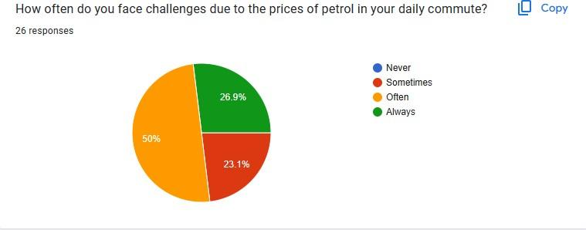

Appendix B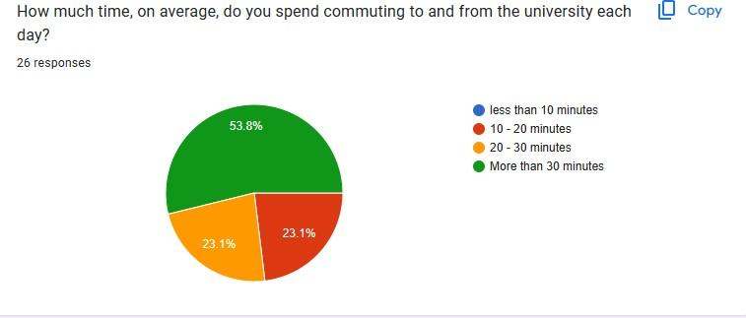

Appendix C

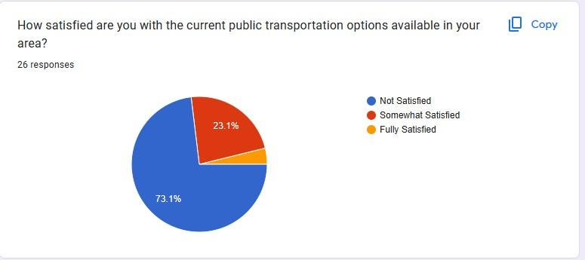

Appendix D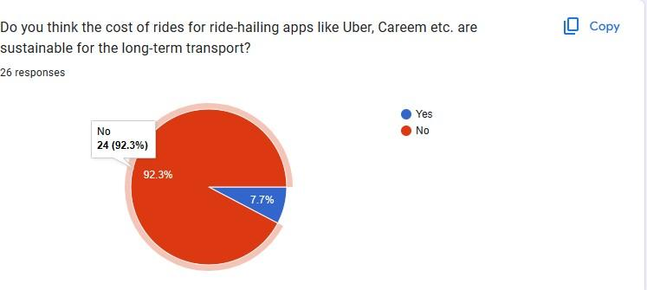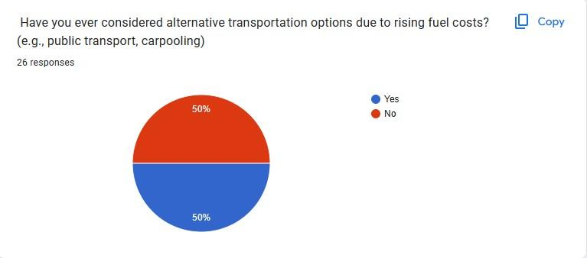

Appendix E

Appendix F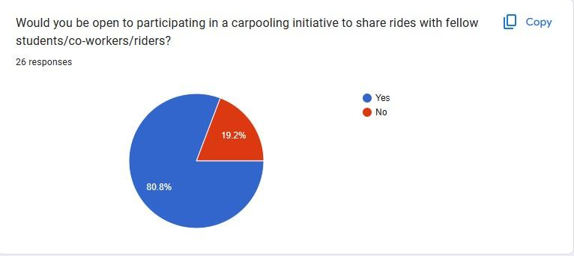

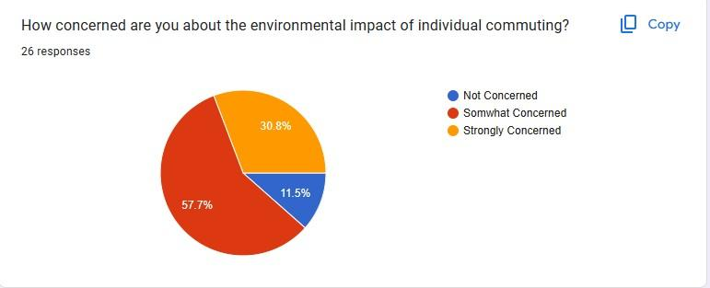

Appendix G

Appendix H

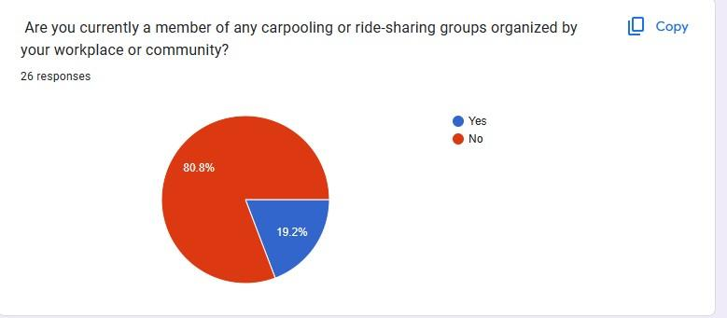

Appendix I

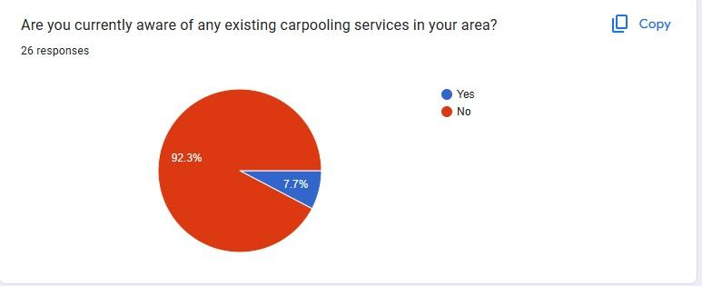

Appendix J